This has been an amazing year of experiencing the grace of God. As we recounted these events, we see God’s gracious hand guiding our ministry. To God be the glory!
Baptismal Service, Easter Sunday
Easter Sunday was especially joyous as we celebrated not only the resurrection of our Lord but also nine baptisms within our combined congregations. Our creative leadership secured an inflatable super tank for this remarkable occasion as we do not have a built-in baptismal tank on-site. We thank God for the following candidates who were baptized: Tao Do, Vincent Hua, Hai Nguyen, Nga Nguyen, Thuy Nguyen, Yen Pham, Ca Tran, Tien Tran, Doan Vo.
English Ministry Congregation: Easter Café
This café was a challenge to host, as we were without a pastor at that time; yet God gave us the ability and resources to spearhead this event with a ministry team of around twelve people. It was a huge effort decorating and providing food, fun, games, a drime and getting a guest devotional speaker. God blessed our efforts abundantly and not only did we grow in our communication skills, leadership skills and interpersonal skills but God drew in around sixty people to attend this event. Good interactions occurred with new people and thus, we built new relationships while renewing old relationships. Many people were moved by the drime presentation which reminded us that no matter how far we have fallen, Jesus will protect us if we will submit to Him.
English Ministry Congregation: Winter Camp
Theme: “Lead and Be led.” This camp was attended by about 130 delegates. This is a joint, annual event with Edmonton Vietnamese Alliance Church, Calgary Vietnamese Mennonite Church and churches from Saskatchewan and British Columbia, held at Camp Nakamun during the Family Day long weekend. The most significant thing that made it worthwhile to attend this camp was the depth of love and fellowship that we experienced as we gathered around the dinner tables and for small group times. These small groups were mixed groups, to foster greater interchurch relations. It was inspiring to see young people growing closer to God and encouraging each other with their faith journeys.
Spring Camp
The Vietnamese theme of our Spring Camp was “The Church in the 21st Century.” The English theme was “Image of God.” This camp is an annual event held on the Victoria Day long weekend at Sunset Point Camp, for the last six years now, and God has blessed this ministry and caused it to grow. It is a joint camp of both Vietnamese Ministry and English Ministry Congregations within Mennonite, Baptist and Alliance churches across Alberta. The love of God has been evident in drawing diverse families together at this camp. It has been a refreshing experience for all delegates, to hear testimonies from each other and to be able to get away from the busyness of life to focus upon spiritual formation. It was a great experience to learn to work together to make this camp a success in the areas of worship scheduling, cooking and the cleaning up; therefore, through this joint ministry, we experienced the love of God together as we learned to grow in being a unified body of Christ. Special relationships have been developed through this camp, which has fostered greater intimacy and deeper community.
Building Fund-Raising Event
The Lord provided us with the opportunity to purchase our existing church building and God moved our members to vote in favor of proceeding. Therefore, in an effort to allow everyone to actively participate in helping with the purchase of our church, we devoted one Sunday to raising building funds and the Lord moved our congregants to pledge $70,000.00 for our building. Thus, God blessed us in this way with funds for our down payment. If the Lord is willing, we will take possession of the church building by December 19, 2012. Special thanks to Pastor Ken Tse and the Edmonton Chinese Mennonite Church for their support of this sale. Also, we offer our deep, heartfelt thanks to the entire Executive Committee of Mennonite Church Alberta for their generous support, leadership and guidance in closing the deal for the purchase of our church building.
Camrose Jay Walker Event
This was a second fund-raising event and this one occurred shortly after our Spring Camp. The women put their gourmet culinary gifts to work and brought in marinated meats, which they skillfully crafted beforehand into frozen, mouth-watering Kabobs on skewers. They also brought in frozen succulent spring rolls and other miscellaneous edible delicacies to be sold for the purpose of fund-raising both for missions and for our church building. God blessed the dedicated, toilsome labors of the women by helping them to bring in about $4,000.00 through this arduous event. Eighty percent of the funds were allocated to the building fund and twenty percent was allocated to overseas missions.
Sponsorship of Refugees from Cambodia
Two years ago, the Canadian government opened up the opportunity to sponsor refugees from Cambodia. Therefore, our church started the process of applying to sponsor a refugee family. This would mean that we would be responsible for them for a full year as they would not be allowed to apply for any social assistance programs. God provided our church with one refugee family to take care of. This was a couple with one son and one daughter. They came over in September 2011 and our church was responsible for them. The Lord was gracious to this family and guided us in this process of assisting them with their adjustment to this culture, socially and financially. As well, through the assistance of our church, God graciously provided for them the means to secure food, clothing, shelter and jobs.
Evangelism Explosion (EE) Committee
God has gifted several members of our church for evangelism outreach. They formed an Evangelism Explosion Committee, which focuses on evangelizing beyond the four walls of our church. Their ministry focuses on reaching out to the Vietnamese at the super markets in downtown Edmonton. The EE Committee would pass out Christian literature and interact briefly with the Vietnamese to see if they know God and they would share their testimonies as well. God has blessed this ministry with much fruit and we have seen quite a few people come to our church through this ministry.
English Ministry Congregation: Interchurch Events
These events include a “PWT” (Praise Worship and Testimony) meeting with the English congregants of the Edmonton Vietnamese Alliance Church and then on a separate occasion, with the Calgary Vietnamese Mennonite Church. This year we have started to host these interchurch events and these events will in turn be hosted at the other churches involved. Each PWT meeting provides us with an inspiring time of worship and testimonials which are a great source of encouragement, as we see how God is moving amongst our churches. They also provide us with opportunities to learn from one another’s differences in worship styles and foster deeper interchurch community.
2012 Christmas Outreach Program
Vietnamese Ministry Congregation: This year, the Evangelism Explosion Committee plan to invite guests to attend a Christmas concert, on
Saturday, December 22 at 7pm.
English Ministry Congregation: This year our English Ministry Congregation is planning to host our annual, elaborate Christmas Café night on Sunday, December 16th from 5pm to 9pm. This will be a full dinner event with door prizes, games, open mic session, a presentation of a pre-recorded play directed and produced by the youth fellowship (“Footsteps” Fellowship) and a concluding devotional talk, entitled “Christmas, A Time for Homecomings” by Dr. Vernie Yee. This is an evangelistic outreach.
Submitted by Pastor Thomas Pham, Senior Pastor and Pastor Kuen Yee, English Ministry Pastor
Edmonton Vietnamese Mennonite Church

Installation Service for Pastor Kuen Yee
On behalf of the Edmonton Vietnamese Mennonite Church, I bring greetings to all the member churches in Mennonite Church Alberta. May the Lord bless all of you this Christmas season. I would like to take this opportunity to share the wonderful things that the Lord has been doing in our church. Since December 2010, our English Ministry was without an English Ministry Pastor until September of this year. In our church's history the Lord has always blessed us with faithful servants who would help lead our youth. When one departed, God would prepare someone else to take the pastoral role for the English-speaking youth. However, since the departure of our last Youth Pastor in late 2010, no replacement could be found. At that time, the English Ministry had started a new worship service, separate from the adult worship service. This was a very challenging time for our youth because the majority of our young adults had left the group, leaving a younger generation that was smaller numerically. It was a challenging period for them as they had difficulty seeing a future in the church, let alone continuing an English Ministry without a pastor. It was also stressful for the adult church, as parents empathized with their children's concerns. However, God provided much encouragement and strength through prayer and our youth did not give up but continued to move forward, stepping up to the challenge before them, against all odds, trusting always in the Lord. I truly believe that the spiritual growth in our youth over this past year could not have been achieved, if not for the challenges God placed before them. Though it has not been easy, we can see God’s hand of blessing upon us. I want to take this opportunity to thank all the guest clergy and speakers who have delivered the Lord's message to our English Ministry for these past years when we were without a pastor.
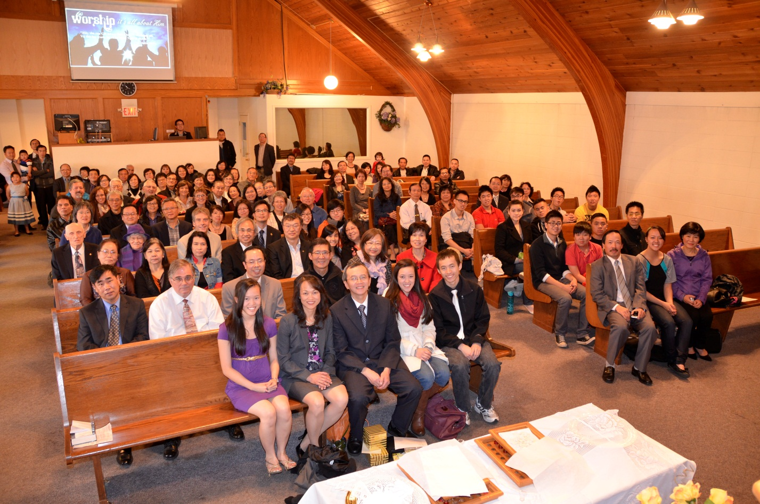

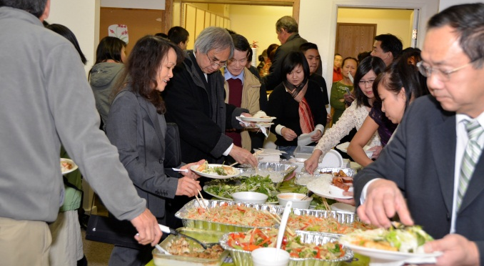
Our entire church has been faithfully petitioning the Lord to provide us with a pastor to lead our youth, trusting the Lord to provide. In September of this year the Lord answered our prayers. Pastor Kuen Yee, formerly with the Christian and Missionary Alliance of Canada, accepted God’s call to serve as our English Ministry Pastor. We are very grateful to have Pastor Kuen Yee, who is more than qualified for this position, commit to providing spiritual leadership for our English Ministry. This reaffirms to us that when we faithfully and patiently trust in the Lord, He is always “able to do immeasurably more than all we ask or imagine” (Ephesians 3:20). Though we initially prayed for one pastor, we were given two. Pastor Kuen Yee's husband, Dr. Vernie Yee, also an ordained minister, volunteered to play a supporting pastoral role. Our congregation is very blessed that Pastor Kuen Yee has accepted the position as English Ministry Pastor and her installation service was held October 14, 2012. We would like to thank Rev. Dan Graber, who officiated the installation service. Amongst our many guests of family, friends and colleagues, were several distinguished guests such as the Honorable Judge, Geoffrey Ho (Provincial Court of Alberta, Youth Court), Sharon Wallish-Murphy (owner of Wallish Greenhouses in Sherwood Park), and May Waymen (the most senior guest, at age 95). At the installation, an open invitation was made for congregants to come forward to lay hands upon Pastor Kuen and Dr. Vernie Yee and commit them to the service of the Lord. Afterwards, a delicious Vietnamese luncheon commemorated this special occasion.

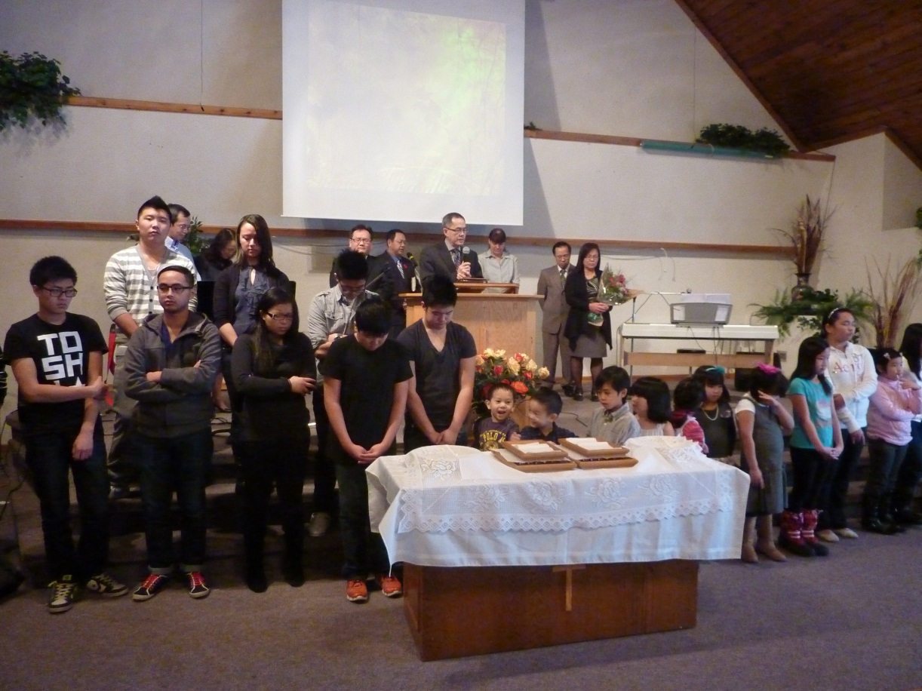
Clergy Appreciation Day
October is National Clergy Appreciation Month, with the second Sunday in October being Clergy Appreciation Day. In order to commemorate this day as joint congregations, our Clergy Appreciation Day was moved to the first Sunday in November. In view of this, we celebrated by giving our Senior Pastor, Pastor Thomas Pham and Mrs. Pham, special recognition for their faithful service of thirteen years, ten of which Pastor Thomas served as Senior Pastor. We are deeply grateful and appreciative of their devotion to ministry and their leadership in service. Also recognized was Carol Saunders, for her devotion to our Children’s Ministry, and Pastor Kuen and Dr. Vernie Yee for their commitment to English Ministry. The congregation presented all of them with special words of appreciation and gifts. We lift our hearts with thanks and praise to God, for He has indeed blessed our congregation through their dedicated service.

Submitted by Vu Huynh, Elder: Youth & Children’s Ministry
Edmonton Vietnamese Mennonite Church
Seeing God in My Life
By Deborah Yee
(A Grade 10 Student)
“So do not throw away your confidence; it will be richly rewarded. You need to persevere so that when you have done the will of God, you will receive what he has promised.”
Hebrews 10:35-36
I’m still not accustomed to talking about my faith and struggle with knowing the right thing to do in situations with non-Christian friends. However, this week, I saw God through my conversation with a friend. Despite her amazing personality, her ideology on life creates a lonely picture. No, I didn’t bring her to Christ but I did give her some understanding into my faith and showed her that she does not have to live her life alone. And maybe that brought her one step closer to God. For me, though, it showed me that, even with my fears and imperfections, God is with me and working through me. I shouldn’t have to worry because God is always next to me, giving me strength to win my battles.

