Over the last six months, we have experienced God’s blessings and so we know that the gracious hand of our Lord is with us. Therefore, we can only cry out as David did, “Bless the Lord, O my soul, And all that is within me, bless His holy name! (Psalm 103:1)
Baptismal Service, Easter Sunday
Easter Sunday was especially joyous as we celebrated two baptisms. Our candidates were Trang Truong and Huong Nguyen. We typically would offer our baptismal candidates a baptismal class prior to their baptism. Afterwards, we offer them a new believers’ class, which is open to all young Christians.
English Ministry Congregation:
Easter Café Night
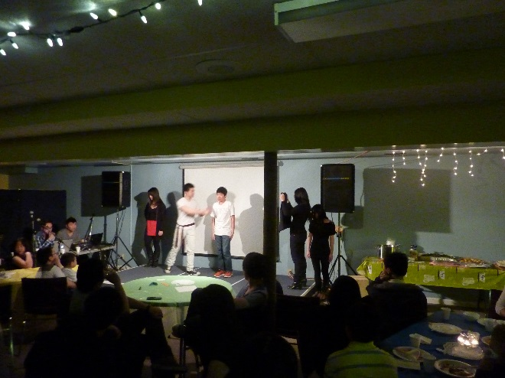
Drime: “Redeemer” presented by our youth group
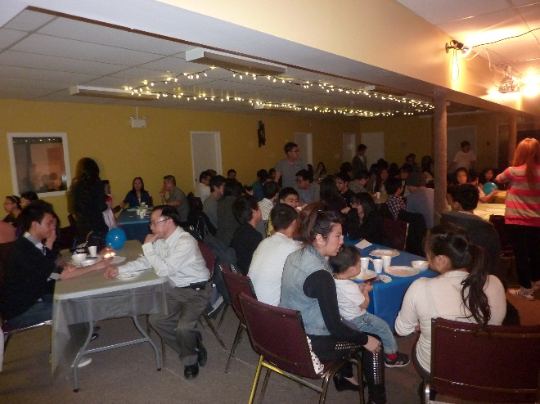
Some of the seventy guests at Easter Café
This Easter Café was a challenge to host but it provided our fellowship with a great opportunity to learn to work together and to use their gifts for a common purpose. The women from the Vietnamese congregation prepared and provided the food for our Easter dinner. Their dedicated service was a huge contribution to the success of this event. We cancelled Sunday morning worship so that we may put all of our energy towards hosting this café with excellence.
Easter Café was a fun evangelistic event, starting off with ice-breaker games, some live musical entertainment, open mic, wherein one guest got up and entertained us by beatboxing to any tune requested by the audience. This was followed by a drime, entitled “Redeemer,” depicting Christ’s redemptive work and this drime became a fitting prelude to Pastor Kuen’s devotional message, “Returning Home to the Father,” based on the story of the prodigal son. Her message ended with a challenge to return home to God, our Father and to indicate their desire to receive Christ by raising their hand and praying to receive Christ. They were also given the chance to indicate this desire by filling out a response card. Two guests raised their hands and an additional four guests filled out a response card, indicating their desire to receive Christ. God blessed our efforts abundantly and brought us 70 people to attend this event.
“Praise the Lord, for the Lord is good.” (Psalm 135:3)

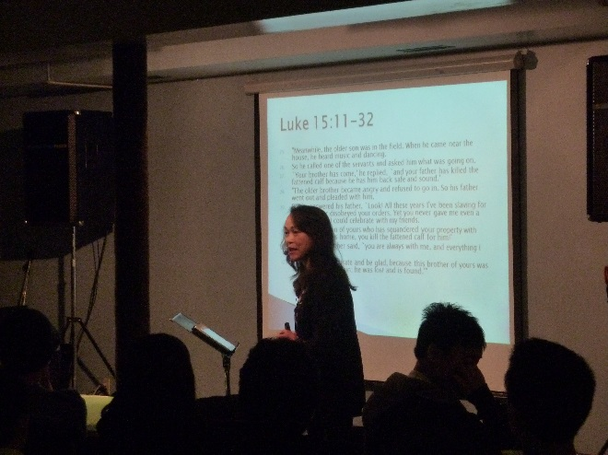
Pastor Kuen, delivering the devotional message “Returning Home to the Father,” based on the story of the prodigal son.
English Ministry Congregation: Winter Camp at Camp Nakamun, on Family Day long weekend.
Theme: “Rethink… Recalibrate…Re-engage.” Keynote speaker: Pastor Chet Kennedy, Beulah Alliance Church.
Devotional speakers: Pastor Kevin, EVAC and Pastor Kuen, EVMC
Keynote speaker: Pastor Chet Kennedy
This camp was attended by about 130 delegates. It is a joint, annual event with most of the congregants coming from the Edmonton Vietnamese Alliance Church (EVAC), Calgary Vietnamese Mennonite Church (CVMC) and Edmonton Vietnamese Mennonite Church (EVMC). A few people came from churches in Saskatchewan and British Columbia. The camp is always held at Camp Nakamun during the Family Day long weekend, which fell on Feb 15-18 this year. The most significant thing was the depth of sharing and the openness to vulnerability while sharing deep personal hurts as well as personal needs during the “Praise, Worship and Testimony” time. We had experienced herein, that “the grace of God appeared” (Titus 2:1a) to us and His presence touched our group in a profound way. Out of love and concern, people surrounded those who shared – praying openly for them and even weeping with them.
Hosting the Theological Studies with Jonathan Bornman, May 9 – 10, 2013
We had the privilege of hosting the theological studies at our church this year. Thanks to the women of our church for their help with providing lunches and snacks. Jonathan Bornman’s teaching was a well prepared presentation of the Islamic faith and it sparked a great deal of lively discussion. Some of us capped off this educational experience with a brisk trek to the local “African Safari” restaurant for a delightful taste of African cuisine.
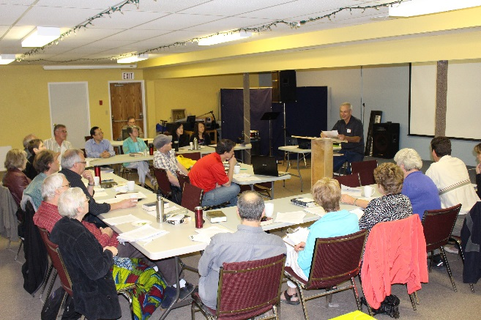
Instructor: Jonathan Bornman
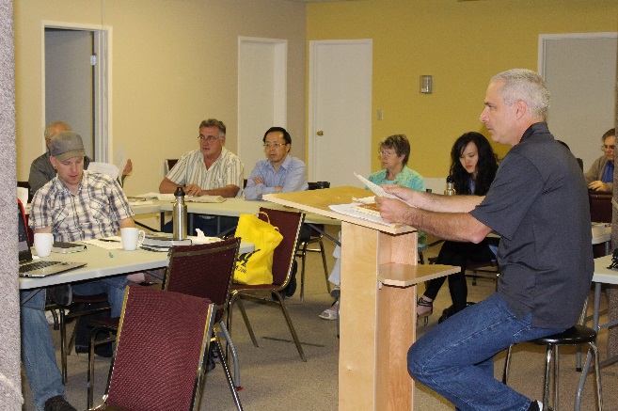
Foreground: Jonathan Bornman
Background right: Rev. Dan Graber, Area Minister
Center: Pastor Thomas Pham
Left: Pastor Ryan Dueck, Lethbridge Mennonite
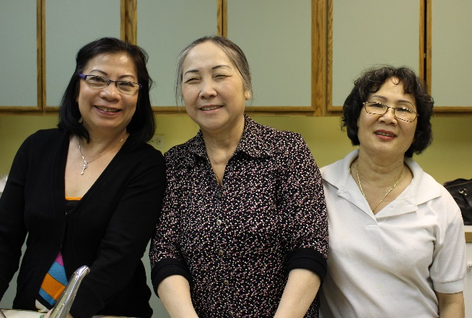
Women who prepared the lunch: Karen Truong, Hai Nguyen, Tuyet Nguyen. Missing: Tina Pham, Ngoc Au

The Impact of Attending the
MCA Theological Training
By Allison Yee
(Doctor of Optometry Candidate, 2015)
“But in your hearts revere Christ as Lord. Always be prepared to give an answer to everyone who asks you to give the reason for the hope that you have. But do this with gentleness and respect.” 1 Peter 3:15
At the MCA Theological Training, I learned a lot about the Islamic faith and witnessing to Muslims. At the end of the conference, we had lunch with some Muslim friends and spent some time talking with them. I have always been timid about sharing my faith with Muslims, but this conference helped me better understand the Islamic faith and gave me more confidence to share my faith with Muslims with gentleness and respect.
I highly recommend attending the MCA Theological Training. God encouraged me and caused me to grow in new ways through this training. It was a great blessing to be there.

Spring Camp on Victoria Day Long Weekend at
Sunset Point Camp, Alberta Beach, May 18-20 Keynote Vietnamese speaker: Pastor Hoa Khuu
Vietnamese theme: Fruitful Living
Keynote English speaker: Richard Sampang
English theme: Intimacy With God.

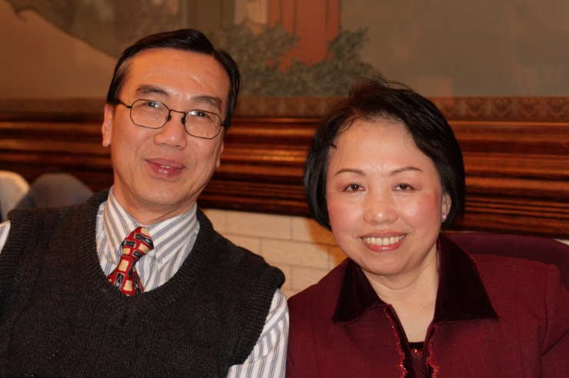
Keynote speaker: Pastor Hoa Khuu and Mrs. Khuu
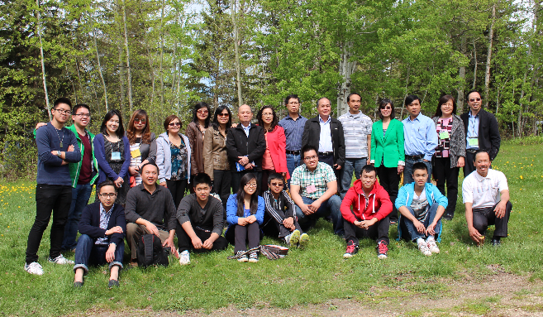
Pastor Thomas’ extended Pham family,
Sunset Point Camp, Alberta Beach, May 18-20, 2013
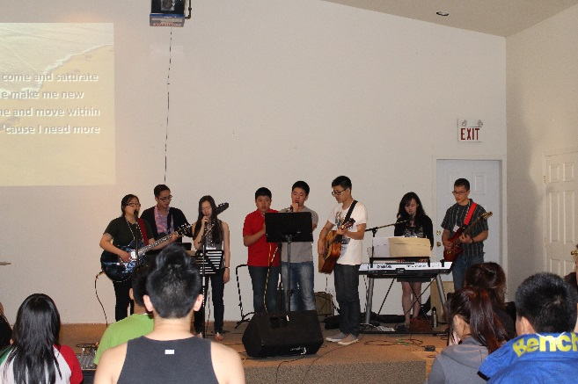
EVMC English Ministry Worship Team
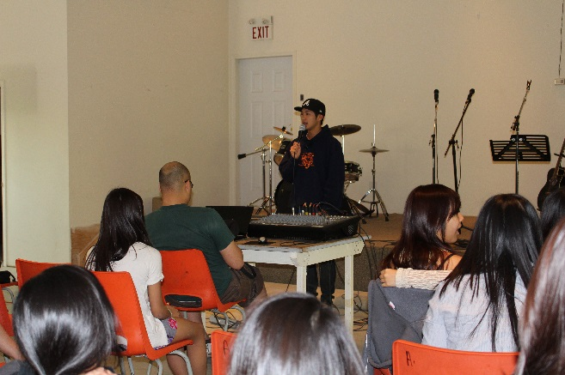
Keynote speaker: Richard Sampang
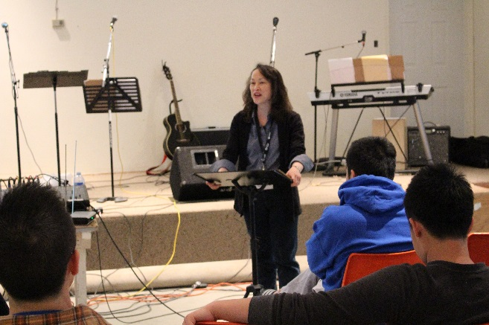
Devotional speaker: Pastor Kuen
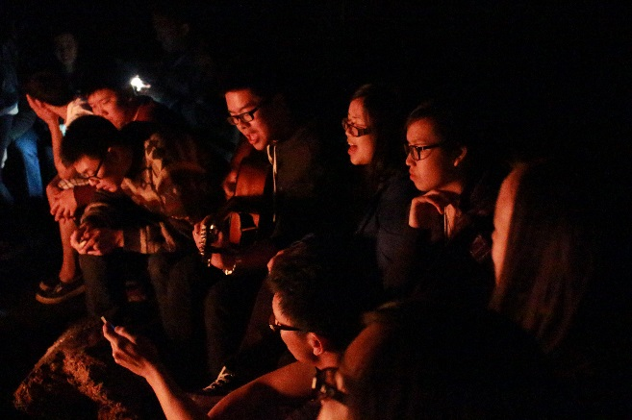
Bond fire
Our Spring camp is an annual event within Vietnamese congregants of Mennonite, Pentecostal and Alliance churches across Alberta and Saskatchewan, very much like our Winter Camp, except that this camp is attended by parents, grandparents and other Vietnamese speakers. It has been held for the last seven years now, and God has blessed this ministry and caused it to grow. We had over 300 delegates this year. One of the highlights this year is that three people accepted Christ at our camp.
Pastor Hoa challenged the Vietnamese speakers to break out of their shell, to die to oneself and grow to become more fruitful. His challenging message touched the delegates and they felt the Spirit of God convicting them. Many of them made a commitment to change their lifestyle to become more fruitful. “Praise the Lord!” (Psalm 150:1)
For the English Ministry, we were blessed with a gifted keynote speaker, Richard Sampang, who is a fourth year student at Ambrose seminary. He challenged and inspired us to reach out and share the love of Christ and the gospel message with our family, friends, coworkers and acquaintances. He shared how that he had failed to do this on a number of occasions, only to see two of his good friends commit suicide. Had he known that they were desperately needing help, he would have reached out to them. He became totally broken over these suicides and used his experience to encourage us to heed the call of God to warn people and to tell them about salvation through Christ. His message was that God will hold us accountable for the blood of the people He brings across our pathway. He held Ezekiel accountable and He will hold us accountable if we do not warn people. What a powerful message!

Massive Renovations Project in Preparation for
Dedication service: Sept. 15, 2013 at 10:30am
We want to give special thanks to our volunteer interior decorator, Siew Leng Low, of Expressione Dolce, for her help with every stage of our new design. Our renovations included putting in new slate tiles in the foyer, stairs, and entrance of our church. All the toilets have been replaced as well. The entire church was repainted, inside and outside. The orientation of our basement worship center has been changed and the basement has been rewired for better acoustics and better lighting.
The main sanctuary sound booth has been torn down and rebuilt with new audiovisual equipment. We also wired our church for network capabilities and we have full internet access throughout all levels of our church building. As well, we have our own church website now, searchable under our church name or http://www.evmchurch.ca/ and soon we will be posting our sermons onto this site as well.
Also, “Thank you” to Siew Leng Low for painting the wall mural in the nursery and to the ladies of the Daybreak Bible Study Group from Beulah Alliance Church for their generous donations of time, money and decorations for the nursery. “Praise the Lord, for the Lord is good!” (Psalm 135:3)
New carpets will be laid this summer and a new baptismal tank will be installed as well. Thus, we welcome donations for our new baptismal tank.
This is an open invitation to everyone.
Please come to our church dedication service on
Sunday, Sept. 15, 2013 at 10:30 am
Edmonton Vietnamese Mennonite Church
10324 – 107 Ave., Edmonton, AB
Tel: (780) 448-1950

Congratulations to all of our graduates!
High School Graduates
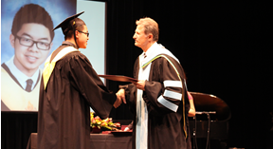
Elisha Pham, Old Scona Academic
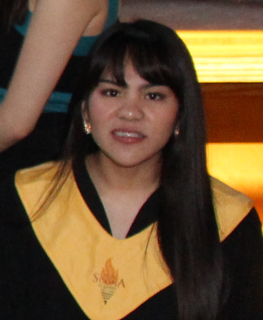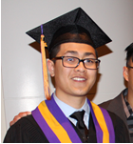
Lauren Hidalgo Joshua Nguyen
Old Scona Academic Archbishop MacDonald
Junior High School Grant MacEwan University
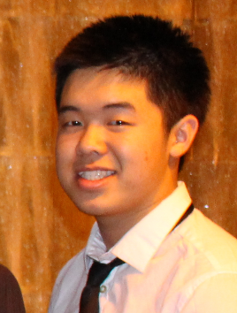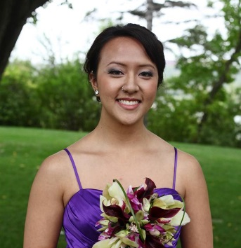
Isaiah Pham Lara Tang, Music diploma
Florence Hallock in Recording Arts.
Summer 2013
Evangelism Explosion (EE) Committee
God has gifted several members of our church for evangelism outreach and this summer, their ministry will again focus on reaching out to the Vietnamese in downtown Edmonton.
Alpha Course
Plans are underway to capitalize on the upcoming media campaign to hit all of Alberta mid-August through mid-September. The “Question Everything” and “Why?” media campaign will direct people to look for a local church to enroll in an Alpha course. We hope to become listed and to train our congregants to run the Alpha course as an evangelistic outreach and as a means of equipping our saints for more effective spiritual service for God. Because He has blessed us with much, we will endeavor to give Him much – to return to Him much blessing and praise. “Praise the Lord, for the Lord is good!” (Psalm 135:3)
Other Churches and Events
Chin Church
We had the privilege of opening up our church to welcome the Chin people to use our church as their place of worship.
Ethiopian Church and Spanish Church
An Ethiopian church and a Spanish church also meets three times a week at our church, pastored by Pastor Terefe Sereke and Pastor Nick Flores respectively.
English as a Second Language (ESL) classes
The Edmonton Mennonite Center For Newcomers has organized three separate sets of ESL classes, each meeting twice a week in our church for a total of six ESL classes, primarily for senior citizens. It has been a blessing for us to host these classes.
North American Vietnamese Mennonite Fellowship Conference
To be held at: Winnipeg, Aug. 2-4, 2013
Keynote Speaker: Vernie Yee
Theme: Discipleship: Matt. 28:19
This is a biennial conference of all Vietnamese pastors and delegates throughout North America. This year, the conference is at the Winnipeg Vietnamese Mennonite Church and it provides a forum for networking, overseas missions, and mutual encouragement.
Indeed, as we reflect upon what God has done for us and how He has blessed us, we say, as David said, “Bless the Lord, O my soul, And all that is within me, bless His holy name!” (Psalm 103:1)
Submitted by Pastor Thomas Pham, Senior Pastor and
Pastor Kuen Yee, English Ministry Pastor
Edmonton Vietnamese Mennonite Church

